Unit 10: Sequences: Recursive Rule for Arithmetic and geometric.

Lesson 10-3

Objectives:

* I can identify an arithmetic sequence & list its terms.
* I can identify the common difference in an arithmetic sequence & calculate the nth term.
* I can write the recursive rule or the explicit rule of an arithmetic sequence

Agenda:

* Video: Power point with notes
* Practice
* Application
* Summary: Closing with Fibonacci sequence

Focus Questions:

1. How do we write an explicit rule and a recursive rule for an arithmetic sequence?
2. What is the connection between arithmetic sequences and linear functions?
3. Homework 10-3

Quiz on lesson 1

Reminders: Test corrections # 9 should be done.

Regents Review 8 take home quiz should be done and checked by me.

[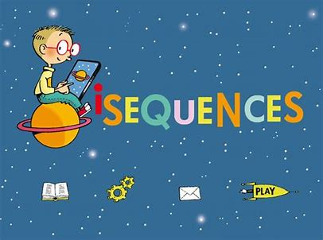](https://www.bing.com/images/search?view=detailV2&ccid=YYi7cbpN&id=4F0BB079BDEC2A25B0F6669B685C85EB80E1E9CF&thid=OIP.YYi7cbpN_8_zNhcDncpUTwHaFj&mediaurl=http://www.javiermairena.net/img/work/isequences/iSEQUENCES-1.jpg&exph=768&expw=1024&q=sequences&simid=607991221902575408&selectedIndex=42)

Do Now: Recursive Sequences

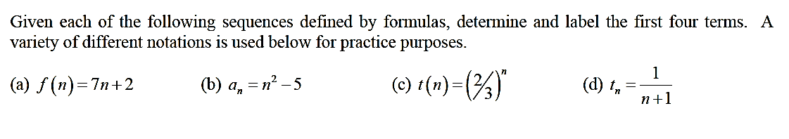







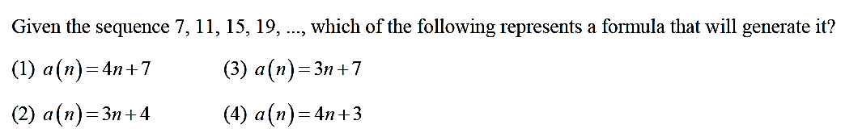

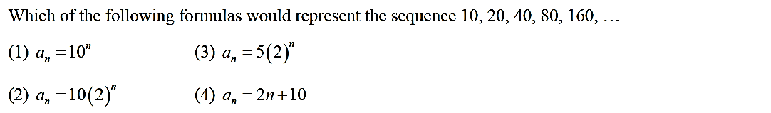

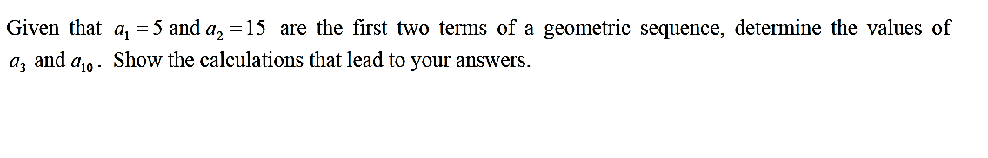4)

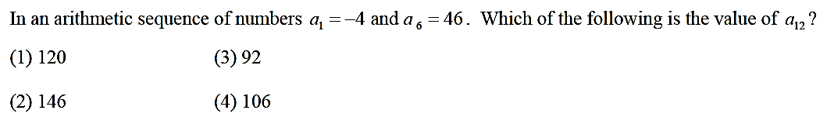

5)

1. 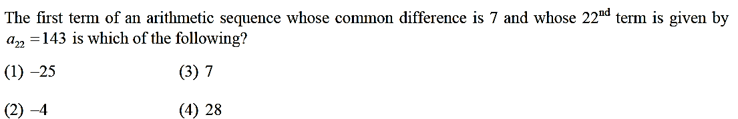

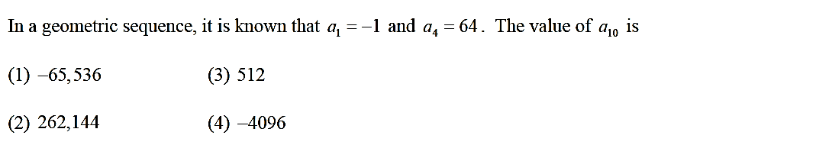

**When will I ever need this?** : <https://www.youtube.com/watch?v=nt2OlMAJj6o>

[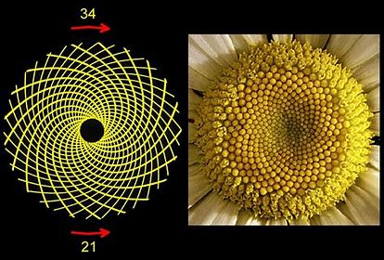](https://www.bing.com/images/search?view=detailV2&ccid=XKkD8SvA&id=6D682E9F6572E487BA66841B71304CEB2B550FDB&thid=OIP.XKkD8SvA0AfWck_Hb6koTAHaFj&mediaurl=http://sciencevibe.com/wp-content/uploads/2015/06/The-Numbers-of-Fibonacci-and-Nature-2.jpg&exph=600&expw=800&q=fibonacci+sequence&simid=608035288266379152&selectedIndex=6)**In recursive sequences preceding terms are used to define the next term of the sequence.**

**Arithmetic Sequences can be written explicitly or recursively.**

1. For example, Given the sequence {13, 18, 23, 28 …}
2. Generate the explicit definition for this sequence.
3. Let’s look at the recursive definition.

Note:  is given as part of the definition.

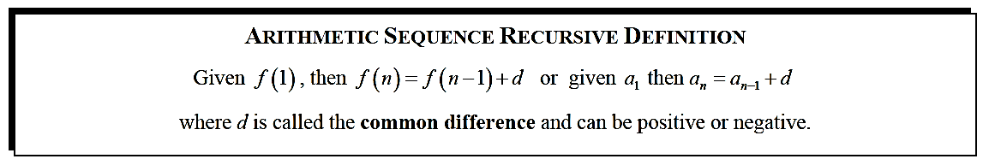

One of the most famous of all **recursively defined** sequences is known as the **Fibonacci Sequence**. Let’s play around with it in the next exercise.

The Fibonacci Sequence is defined recursively as follows:

$a_{n}=a_{n-1}+a_{n-2}, a_{1}=1, a_{2}=1$

Evaluate $a_{3}$, $a_{4}$, and $a_{5}$

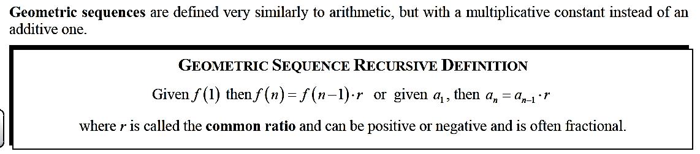

1. **Generate the next 3 terms of the geometric sequence and write the equivalent explicit equation.**

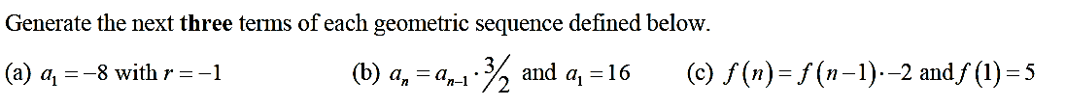



Name: ________________________ Date: __________Recursive Sequences Homework 10-3

Find the first 4 terms in each sequence.

Hint: Start with n = 2, then n = 3, then n = 4.



2)

Hint: Start with n = 1, then n = 2, then n = 3.



3)



4)

Hint: Start with n = 2, then n = 3, then n = 4.

5) 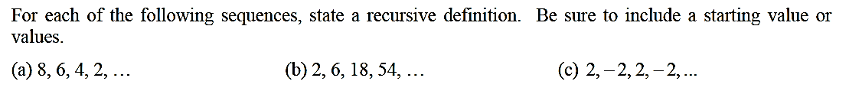Do one problem only: either a, b or c.

Start Portfolio:

[](https://www.google.com/imgres?imgurl=http://muslimresearchers.org/wp-content/uploads/2016/10/Brain.png.625x385_q100.png&imgrefurl=http://muslimresearchers.org/category/creative-corner/&docid=1rmMpFspDtsO7M&tbnid=eVP0hJWLgCGZfM:&vet=10ahUKEwjK9Kqg8enaAhUwhuAKHSKeAVoQMwh_KCMwIw..i&w=616&h=385&bih=647&biw=1280&q=creative%20corner&ved=0ahUKEwjK9Kqg8enaAhUwhuAKHSKeAVoQMwh_KCMwIw&iact=mrc&uact=8)Summary: Exit Ticket

* Write 3 key ideas you learned today:
* Write 2 interesting facts about today’s lesson
* Write about a concept that you might be confused about.